A Chinese Multi-Affection Multi-Modal Dialogue Dataset
Annotation Guidance

Abstract: In the field of NLP dataset development, the current development of multi-affection joint learning models Chinese is relatively slow, due to the serious lack of Chinese dialogue emotional datasets. We try to build a large Chinese multi-emotion multimodal dialogue emotional data set to make Chinese multi-emotion joint analysis feasible. The dataset includes 3,800 video dialogues, including sitcoms such as "My own swordsman" and "iApartment", as well as dramas such as "Romance of the Three Kingdoms" and "The Name of the People", as well as suspenseful dark tone dramas such as "White Night Pursuit" and "Hidden Corners". Among the 3800 multi-modal dialogues, each video dialogue is not less than 10 seconds, and the annotator can view the content of the discourse and watch the video repeatedly. Follow the guidance to finalize the task of text labeling this data. The specific guidance is as follows:
1. Annotation Procedure.
(1) Each annotator will watch a video (with sound and subtitles).
(2) After watching. Combined with contextual text, video and sound, each sentence of this video is labeled with 7 categories of emotion, emotion, irony, humor, pride, and love in the characters.
(3) After all the discourse annotations are completed and saved, select the next video and label them in turn until all slices are finished.
2. Labels
Labeling is mainly 7 emotional tasks for labeling:
(1) Emotions: Joy, Sadness, Anger, Fear, Surprise, Disgust, Neutral.
(2) Emotions: positive, negative, neutral (choose one).
(3) Whether it contains irony: Yes or no.
(4) Whether it contains humor: Yes or no.
(5) Correlation of emotions to emotions: -2 (strong reverse influence), -1 (reverse effect), 0 (no effect), 1 (positive effect), 2 (strong positive effect).
(6) The relevance of satire to humor: -2 (strong reverse effect), -1 (reverse effect), 0 (no effect), 1 (positive effect), 2 (strong positive effect).
(7) Pride: Yes or no.
(8) Love:
Long-term love: buddy love, starting from friends, after long-term contact and natural relationship.
Love at first sight: a passion that shines in the eye, has no emotional basis but can quickly form an intimate relationship.
Empty love: Very rational realistic need feelings, mostly love that introduces blind dates or goes straight to the theme of marriage.
None;
3. Labeling Standard
(1) The labeling process is mainly based on the speaker's words, expressions, tone, actions and other performances to judge the emotional color carried by the speaker.
(2) When labeling each sentence of the video, the words may carry more than one emotion, and the expression of the strongest emotion is the final choice of labeling.
(3) Emotions are mainly divided into positive, negative and neutral. Among them, anger, disgust, fear, and sadness are regarded as negative emotions, happiness, surprise are regarded as positive emotions, and others are neutral.
(4) Whether each sentence contains humor, irony, love, pride and humility. It is up to the labeler to combine visual, textual, auditory, and contextual information to make judgments.
(5) The correlation between emotion and emotion mainly relies on the subjective feelings of the labeler to judge whether the relationship between emotion and emotion in this discourse is positively correlated, negatively correlated or unrelated. and the intensity of their correlation.
(6) The relevance of satire to humor mainly relies on the subjective feelings of the labeler to judge whether the relationship between satire and humor in this discourse is positively correlated, negatively correlated, or unrelated. and the intensity of their correlation.
4. Tips
(1) Please keep quiet, objective, independent and rigorous during the whole process of labeling! Disable pasting and copying!
(2) In the labeling process, the labeling personnel must keep their minds clear to ensure the correct labeling of the multi-task dataset.
(3) In the labeling process, the 7 task options of each sentence require all the labeling, and then allow submission, and all the discourse annotations of the video can be marked on the next video.
(4) The labeling time is 1-2 hours per day, pay attention to the combination of work and leisure, and avoid fatigue affecting the labeling results.
(5) If the annotators have any questions, please ask questions at any time.
5. Requirements for Annotators
(1) Labelers need to have good mental health and have a more mature understanding and discrimination of emotions.
(2) The labeling personnel should conscientiously and responsibly label every sentence of each video clip, and are not allowed to label indiscriminately. Once found, they will be disqualified from labeling and will not be paid the corresponding remuneration for their services.
(3) Have good work literacy, reasonably arrange time, and be able to complete the labeling task within the specified time.
6. Ui Annotation Tool Usage Guide:
(1) Run the tool and environment: eclipse+Tomcat+Navicat (database) to run code.
(2) After entering the homepage, select the sliced video in the video playlist or enter the serial number of the sliced video, and click Start Labeling.
(3) The first version of the annotation main interface in March 2021 (the page design will be improved in the future), as shown in the following figure:
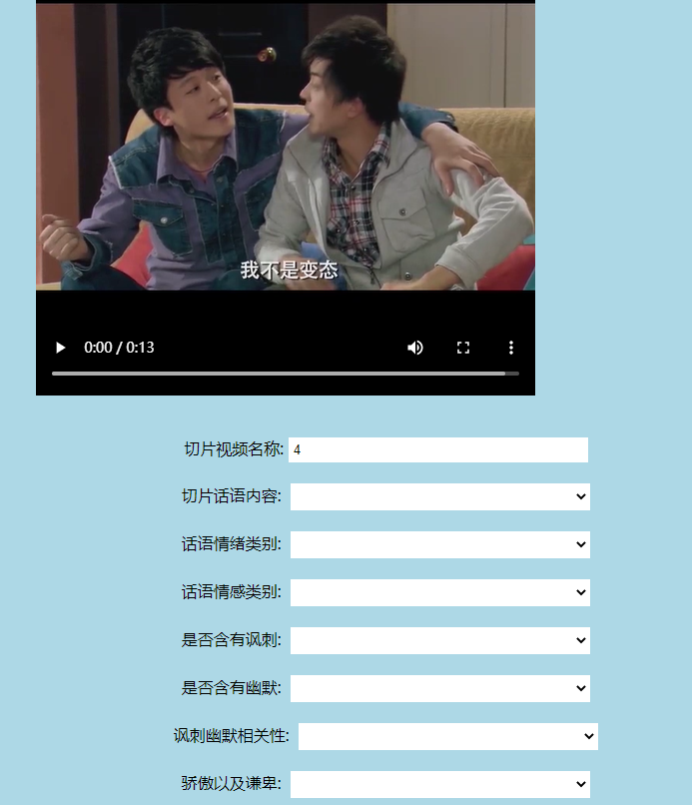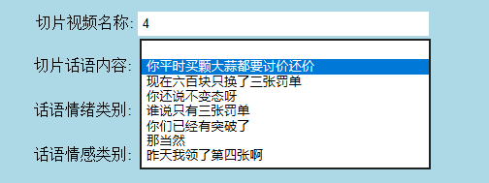
(4) Select the video to label each sentence, label 7 task tags, and click "Submit" to save all 7 tasks. Then proceed to the next sentence annotation until the whole discourse annotation of this slice video is completed.
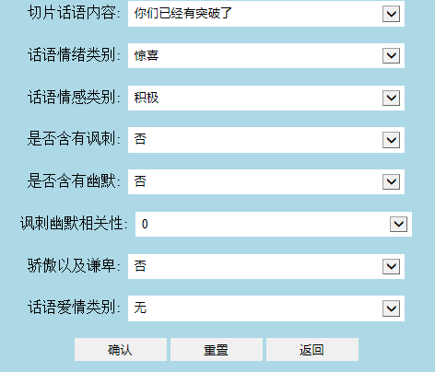

The 7 task tags in which each sentence are labeled are not allowed to be labeled as empty.
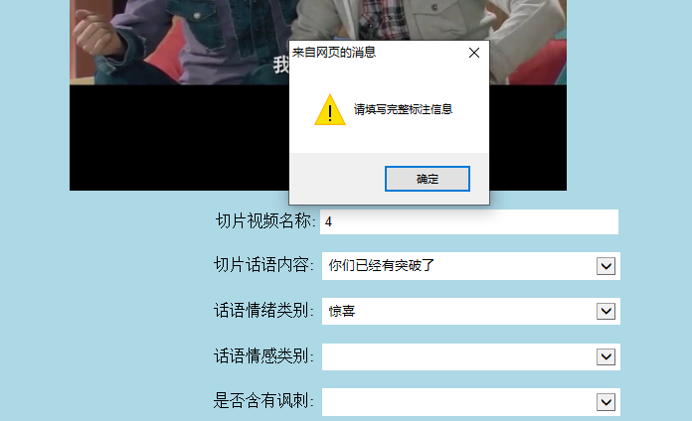
After the annotation is successful, it can be viewed in the database, as shown in the following figure:
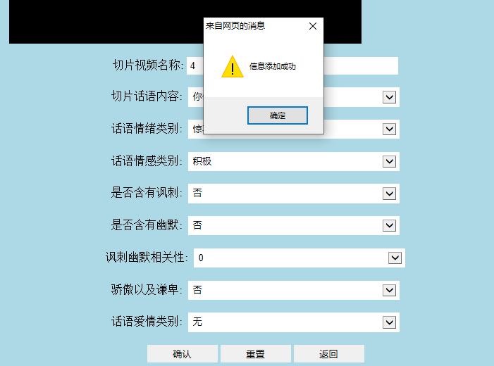

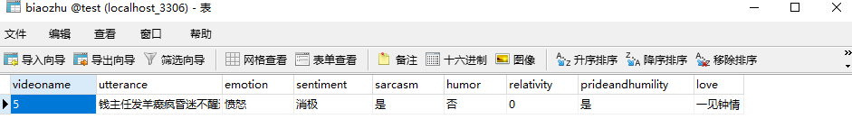
(6) Click the "Reset" button. Empty the text box and reselect the utterance.
(7) Click the "Back" button. Go back to the homepage and select another slice video to annotate.
7. Examples
(1) Good labeling cases:


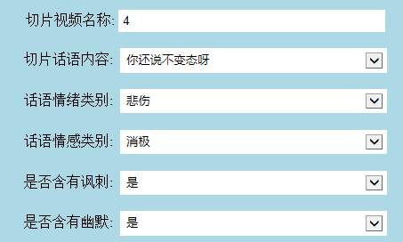
As shown in the second figure, the emotions expressed by the female character of the speaker are negative and sad, and the content of the speech contains irony to the friend, which is ironic. However, considering the contextual content, it is found that there is also a sense of humor, and from the perspective of the viewer or the annotator, it can be seen that there is humor in the discourse. This is a good labeling case, which can correctly identify the emotional color of the speaker's words.
(2) Poor labeling case:

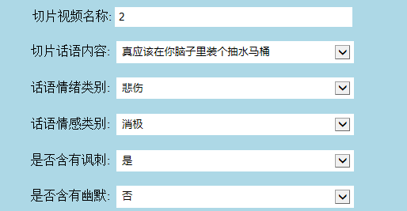

As shown in the image above, the speaker is a female character, and the emotions expressed are anger and disgust. So emotions should be anger, emotions should be negative, and there is irony and humor in the words, so the standard for this video is inaccurate.

